**Dictionary Loop and String Formatting**

Here is an example that combines a dictionary loop with string formatting. The loop iterates over the dictionary and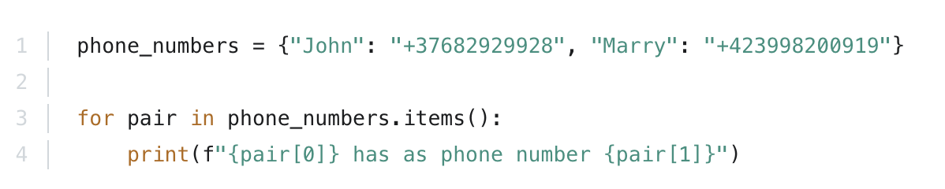 it generates and prints out a string in each iteration:

And here is a better way to achieve the same results by iterating over keys and values: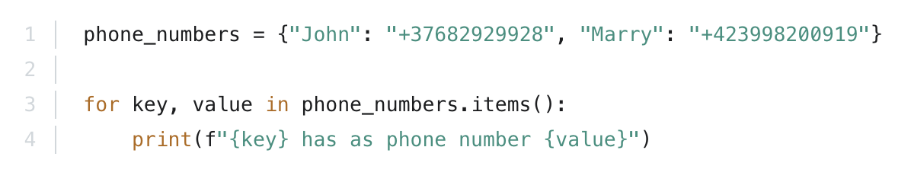

In both cases, the output is:

John has as phone number +37682929928

Marry has as phone number +423998200919